Privacy
Privacy in Snowflake
1. Privacy (in Snowflake)
Definition
In Snowflake, privacy means protecting sensitive data so that only authorized users can access it, and personal or confidential information is not exposed during storage, processing, or analytics.
Why to Use
- To protect sensitive data (PII, salaries, health data)
- To comply with regulations (GDPR, HIPAA, etc.)
- To safely share data across teams and accounts
Snowflake provides multiple privacy controls such as:
- Role-based access control (RBAC)
- Secure views
- Dynamic data masking
- Row access policies

- Role-Based Access Control (RBAC)
Role-Based Access Control (RBAC) is a security model in Snowflake where access to data and objects is given to roles, and roles are assigned to users.
Simple Explanation
- Users do not get permissions directly
- Permissions are granted to roles
- Users inherit permissions through roles

Role-based access control Practical Example
Create Roles
create or replace role admin_role;
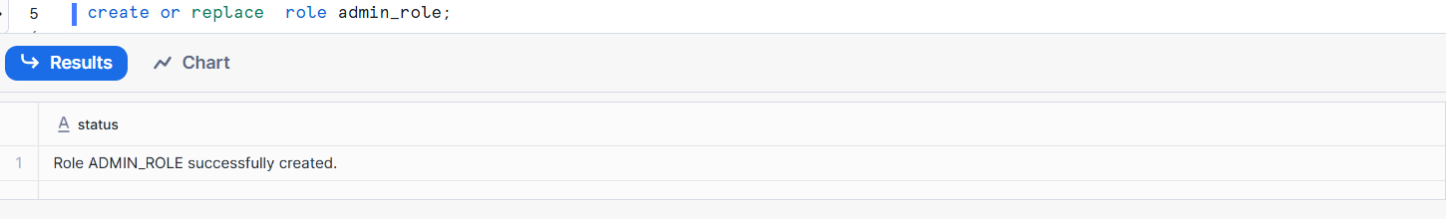
Create analyst_role
CREATE or replace ROLE analyst_role;
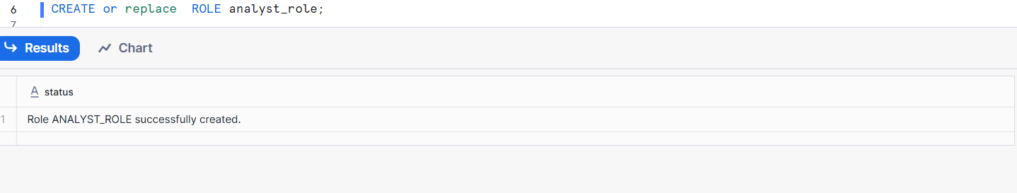
Create ETL _role
CREATE or replace ROLE etl_role;
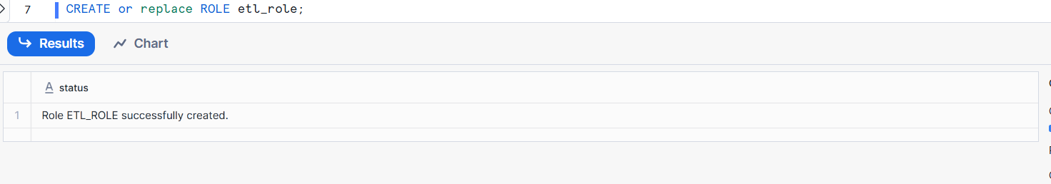
Create DataBase
CREATE DATABASE sales_db;
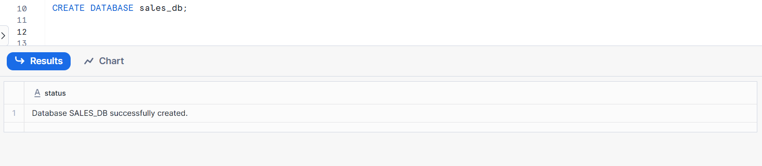
Create schema

CREATE OR Replace SCHEMA sales_db.public;
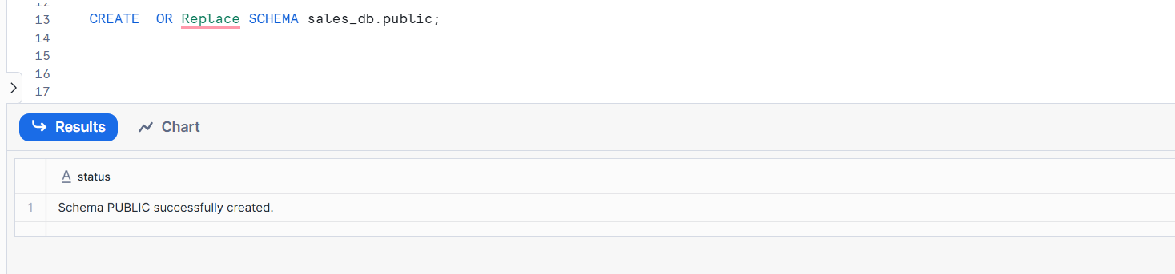
Create table sales_db.Public.sales
CREATE TABLE sales_db.public.sales (
order_id INT,
amount NUMBER
);
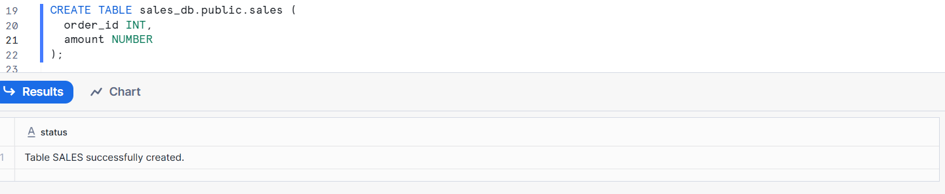
Grant Privileges to Roles
Admin – Full access
GRANT ALL PRIVILEGES ON DATABASE sales_db TO ROLE admin_role;
GRANT ALL PRIVILEGES ON SCHEMA sales_db.public TO ROLE admin_role;
GRANT ALL PRIVILEGES ON TABLE sales_db.public.sales TO ROLE admin_role;

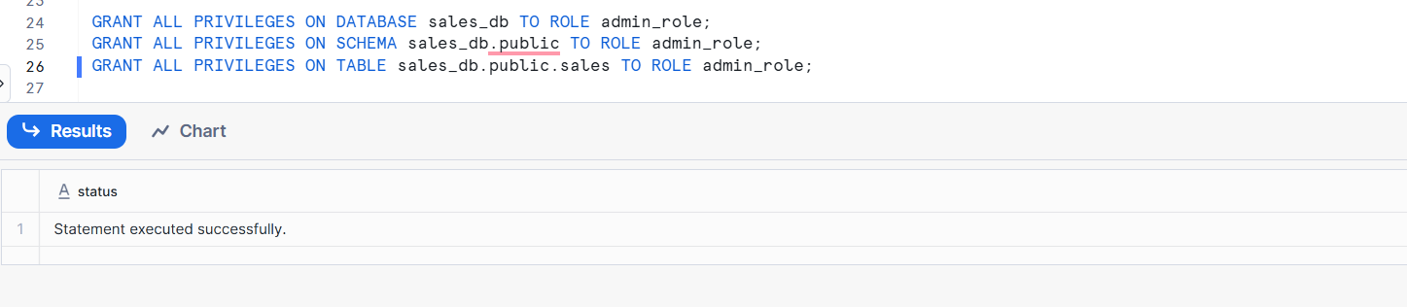
Analyst – Read only
GRANT USAGE ON DATABASE sales_db TO ROLE analyst_role;
GRANT USAGE ON SCHEMA sales_db.public TO ROLE analyst_role;
GRANT SELECT ON TABLE sales_db.public.sales TO ROLE analyst_role;

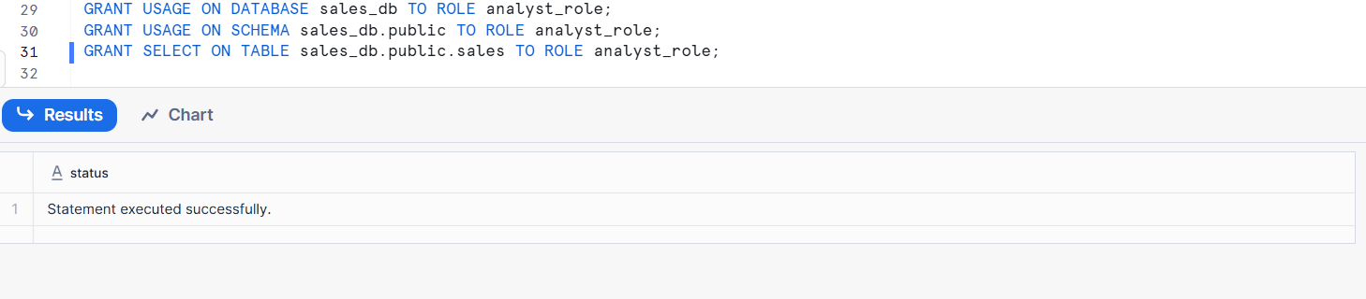

Switch to admin role
USE ROLE SECURITYADMIN;
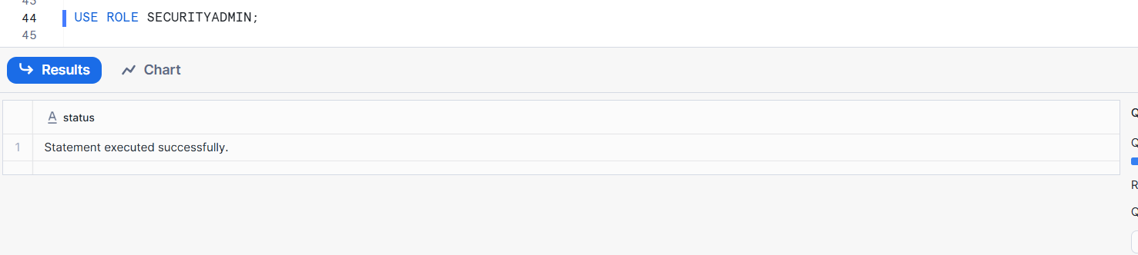
Create the user
CREATE USER ETL_USER PASSWORD='Temp@123';
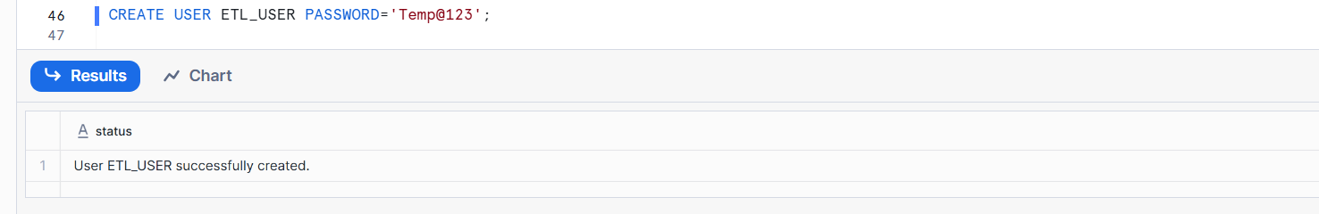
Grant the role
GRANT ROLE etl_role TO USER ETL_USER;
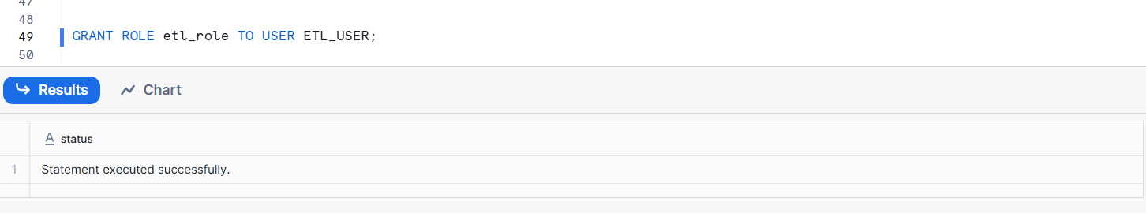

- Secure Views
A Secure View in Snowflake is a special view that hides the underlying table data and query logic, preventing users from accessing or inferring the original data.
- Users can query the view
- Users cannot see base table data
- Used to safely share sensitive or aggregated data
Secure View Practical example
Switch to ADMIN role
USE ROLE ACCOUNTADMIN;
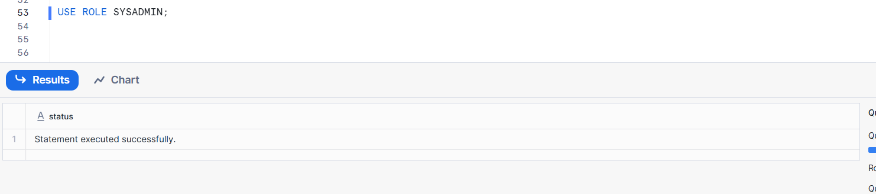
Grant required privileges
GRANT USAGE ON DATABASE sales_db TO ROLE admin_role;
GRANT USAGE ON SCHEMA sales_db.public TO ROLE analyst_role;
GRANT CREATE TABLE ON SCHEMA sales_db.public TO ROLE etl_role;

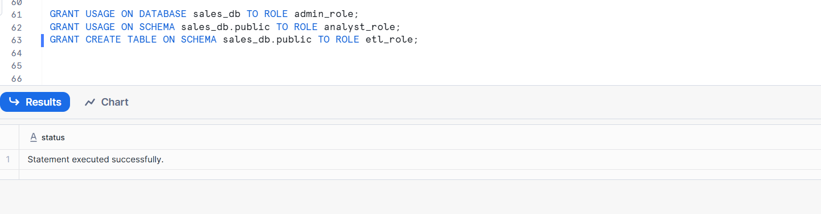
Switch back to Accountadmin role
USE ROLE ACCOUNTADMIN ;
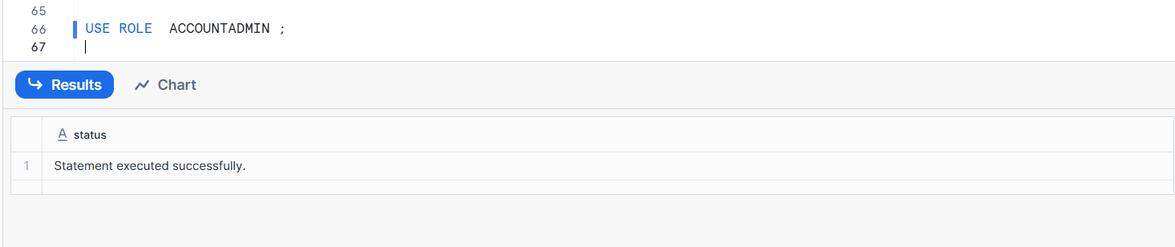
Run Employees table

CREATE OR REPLACE TABLE employees (
emp_id INT,
emp_name STRING,
department STRING,
salary NUMBER
);
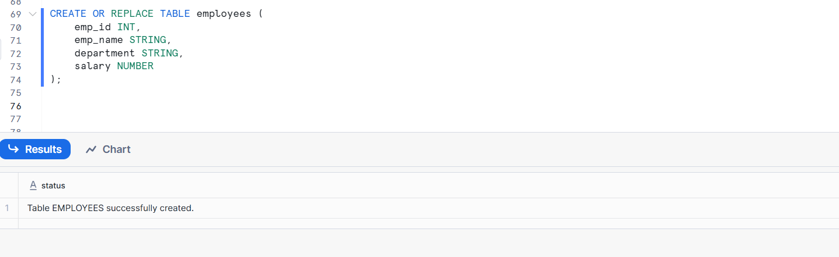

- Dynamic Data Masking
Dynamic Data Masking is a feature that automatically hides or masks sensitive column values based on the user’s role at query time.
- Same query
- Different results for different roles
- Sensitive data is masked in real time
DynamicData Masking Practical Example
Create Table
CREATE OR REPLACE TABLE employees (
emp_id INT,
emp_name STRING,
department STRING,
salary NUMBER
);
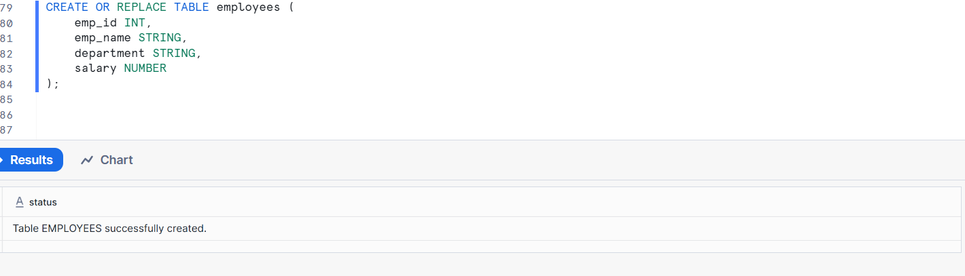
Insert Sample Data

INSERT INTO employees VALUES
(1, 'Ravi', 'HR', 60000),
(2, 'Anita', 'IT', 80000),
(3, 'Suresh', 'Finance', 75000);
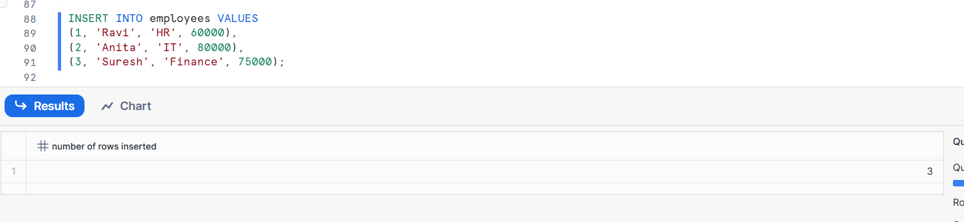
Create Masking Policy
CREATE OR REPLACE MASKING POLICY salary_mask_policy
AS (val NUMBER)
RETURNS NUMBER ->
CASE
WHEN CURRENT_ROLE() = 'HR_ROLE' THEN val
WHEN CURRENT_ROLE() = 'FINANCE_ROLE' THEN ROUND(val, -3)
ELSE NULL
END;

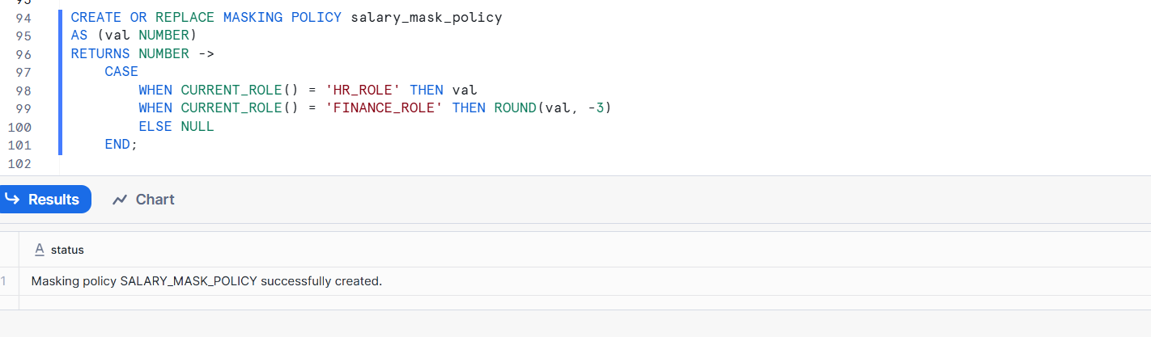
Apply Masking Policy to Column
ALTER TABLE employees
MODIFY COLUMN salary
SET MASKING POLICY salary_mask_policy;
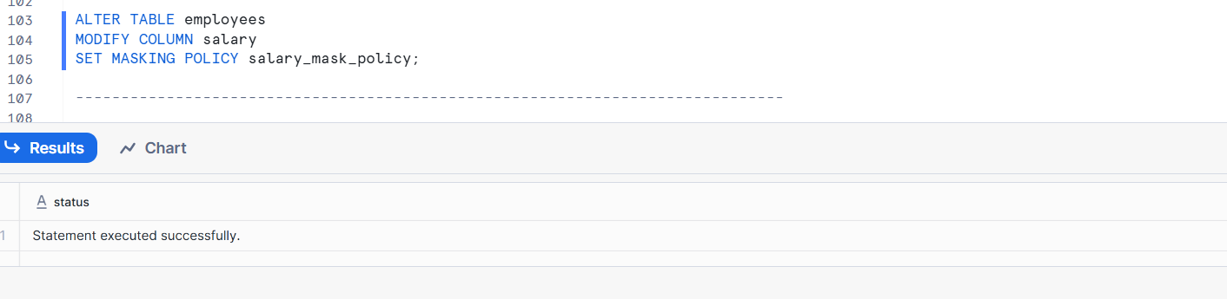
Test as HR Role
USE ROLE HR_ROLE;
SELECT * FROM employees;
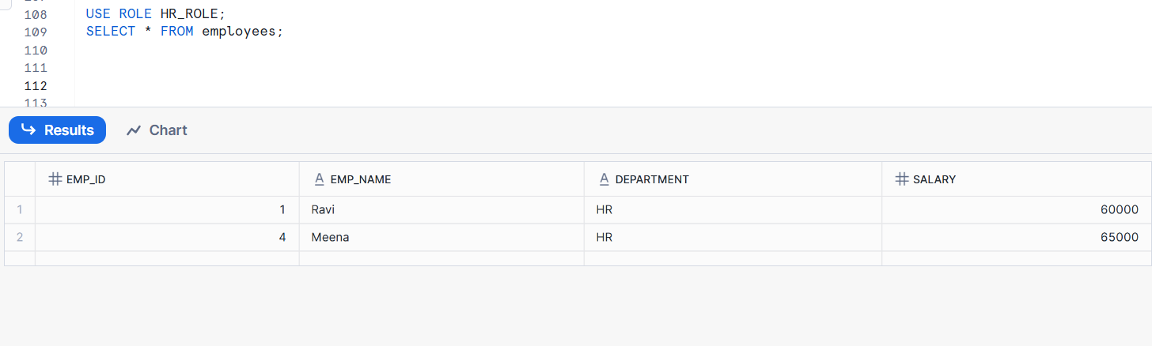

- Row Access Policies
Row Access Policies restrict which rows of a table or view a user can see based on their role or context.
- Users see only relevant rows
- Data is filtered automatically
- Enforced during query execution
Row Access Policies Practical Example
Create Table
CREATE OR REPLACE TABLE employees (
emp_id INT,
emp_name STRING,
department STRING,
salary NUMBER
);
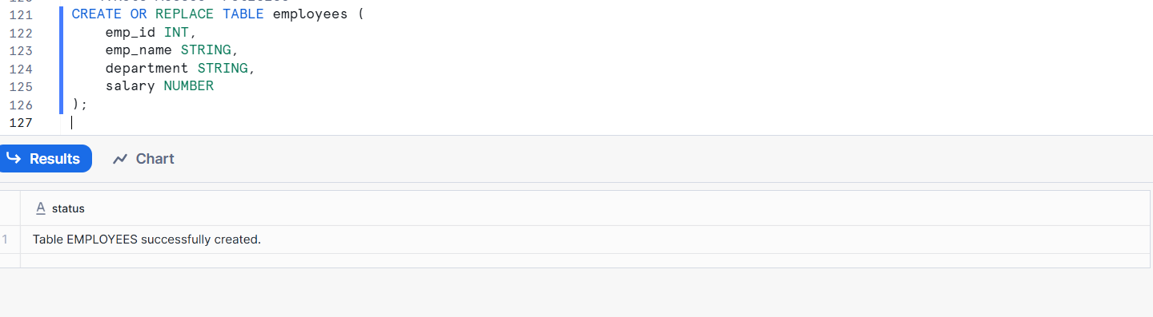
Insert Sample Data
INSERT INTO employees VALUES
(1, 'Ravi', 'HR', 60000),
(2, 'Anita', 'IT', 80000),
(3, 'Suresh', 'FINANCE', 75000),
(4, 'Meena', 'HR', 65000);

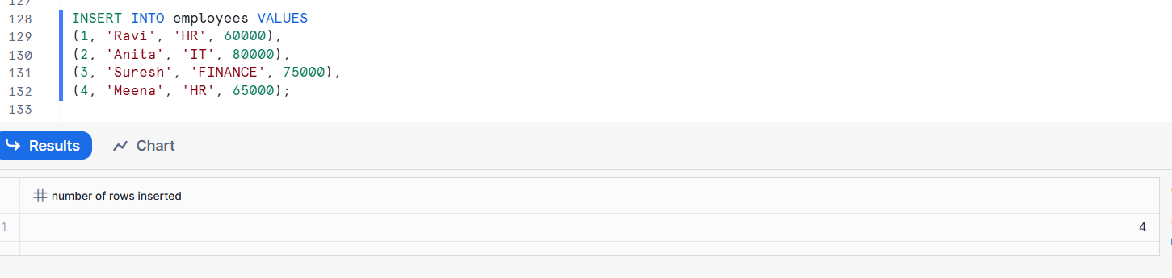
Create Row Access Policy
CREATE OR REPLACE ROW ACCESS POLICY dept_row_policy
AS (dept STRING)
RETURNS BOOLEAN ->
CASE
WHEN CURRENT_ROLE() = 'ACCOUNTADMIN' THEN TRUE
WHEN CURRENT_ROLE() = 'HR_ROLE' AND dept = 'HR' THEN TRUE
WHEN CURRENT_ROLE() = 'IT_ROLE' AND dept = 'IT' THEN TRUE
ELSE FALSE
END;
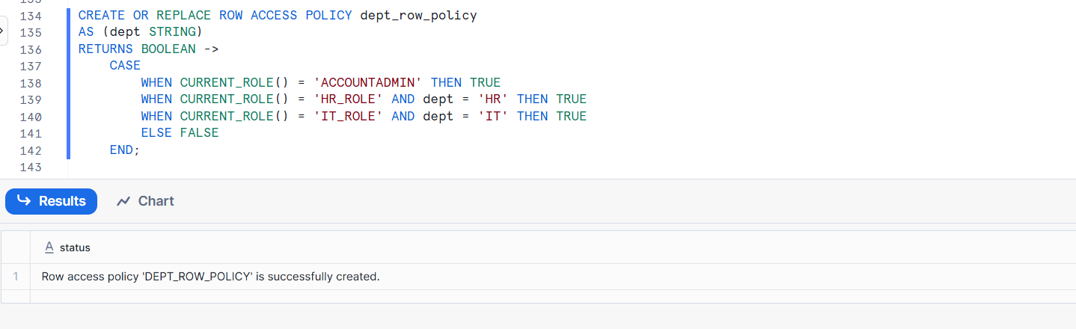
Attach Policy to Table
ALTER TABLE employees
ADD ROW ACCESS POLICY dept_row_policy
ON (department);
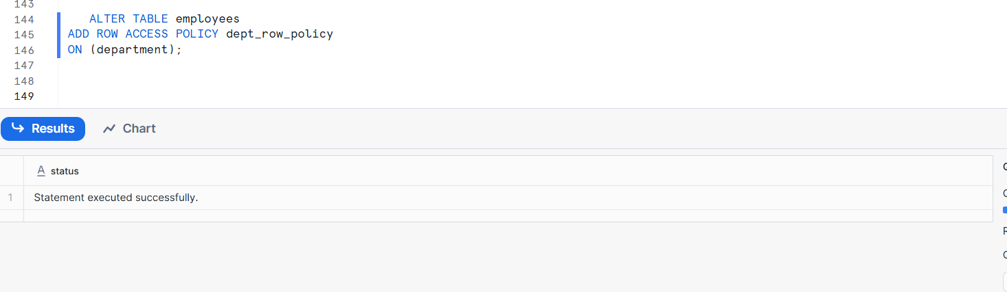
Test as HR Role
USE ROLE HR_ROLE;
SELECT * FROM employees;
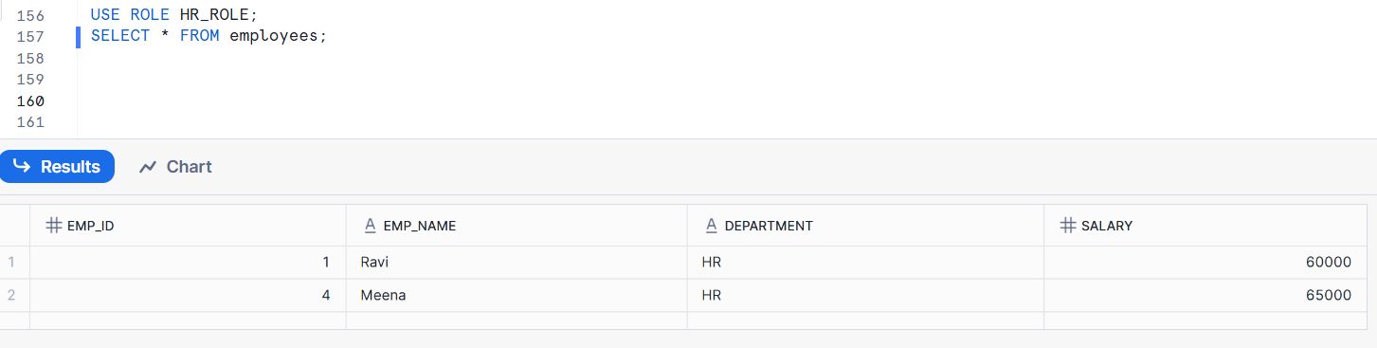
Test as IT Role
USE ROLE IT_ROLE;
SELECT * FROM employees;
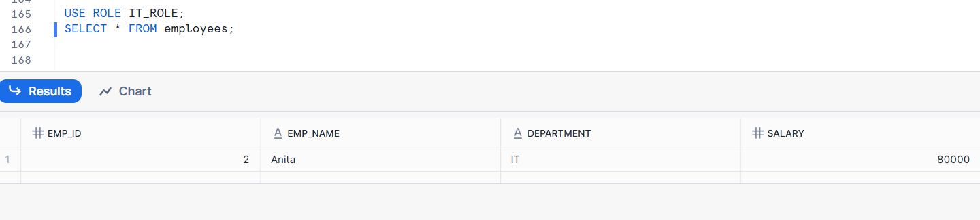

2. Differential Privacy
Differential Privacy is a privacy technique that adds controlled noise to query results so that individual records cannot be identified, even from aggregate queries.
Why to Use
- Prevents re-identification attacks
- Allows sharing analytics results safely
- Protects individual contribution to datasets
Explanation
While Snowflake does not automatically enforce differential privacy on all queries, it can be implemented using SQL logic, secure views, and controlled query patterns.

3. Privacy Domains
A Privacy Domain in Snowflake is a logical boundary that defines how data is accessed and shared under specific privacy rules.
Why to Use
- Different users need different levels of access
- Prevents accidental data exposure
- Supports data sharing across teams or accounts
Snowflake supports privacy domains through:
- Roles
- Schemas
- Secure views
- Data sharing
4. Implementing Differential Privacy in Snowflake
Implementing differential privacy in Snowflake means designing queries and views that reduce the risk of identifying individuals.
Why to Use
- Snowflake is widely used for analytics
- Aggregations can still leak information
- Controlled noise protects users
Common techniques include:
- Aggregation-only access
- Adding random noise
- Limiting repeated queries
Secure views with privacy logic
5. Executing Queries with Privacy Controls
Executing queries in Snowflake means queries are validated against roles, policies, and masking rules before results are returned.
Why to Use
- Prevents unauthorized data access
- Ensures consistent privacy enforcement
- Centralized security control

Before execution, Snowflake checks:
- User role
- Object privileges
- Row access policies
- Masking policies
6. SQL Support for Privacy in Snowflake
Snowflake provides native SQL features to implement privacy without changing applications.
Why to Use
- Easy to implement
- Scales automatically
- No extra tools required

7. Synthetic Data (in Snowflake)
Synthetic Data is artificially generated data that looks like real data but contains no actual personal information.
Why to Use
- Safe for testing and development
- Can be shared externally
- No privacy or compliance risk
In Snowflake, synthetic data can be:
- Generated using SQL
- Stored in separate schemas
- Shared using Snowflake Data Sharing

